SECURE PYTHON LOGIN AND JWT SECURITY POWERED BY PYTHON
&DYNAMIC RBAC &MONGODB WITH FAST API

PREPARED BY: MOLAMANTI THITUPATHIRAO
EMPLOYEE CODE: ZPVY-10105

INDEX

DECLARATION 3
ABSTRACT 4
INTRODUCTION: - 5
OBJECTIVES OF THE PROJECT:- 6
SECURITY IMPLEMENTATION IN THE PROJECT: - 7
PASSWORD HASHING: - 7
What is bcrypt? 7
Why bcrypt instead of plain hashing (like MD5/SHA)? 8
What is re? 9
Implementation in the Project 9
JWT-BASED AUTHENTICATION:- 10
What is JWT? 10
Structure of JWT 10
Why JWT in this Project? 11
Implementation in the Project 11
Login Endpoint 12
RATE LIMITING:- 12
What is Rate Limiting? 12
Implementation in the Project 13
Input Validation:- 13
What is Input Validation? 13
What is Pydantic? 13
What is BaseModel? 14
Implementation in the Project 14
How BaseModel Works in Fast API 14
Advantages of Using BaseModel 14
Role-Based Access Control:- 15
Why RBAC is Important 15
RBAC in Fast API 15
Implementation in the Project 16
Advantages of RBAC 16
TLS/SSL Encryption: - 17
What is TLS/SSL? 17
How TLS/SSL Works 17
Security Event Logging: - 18
Why is it Important? 18
Events to Log 18
Implementation in the Project 19
Demo Project: Secure Login + JWT + RBAC with Fast API and MongoDB: - 19
Objective 19
Features Implemented 19
Example API Endpoints 19
Flow of the Project 20
Project structure 20
Requirements: - 21
Conclusion:- 22

DECLARATION
I hereby declare that the project entitled “Secure Python Login And Jwt SecurityPowered By Python &Dynamic Rbac &Mongodb With Fast API” submitted in partial fulfilment of the requirements for a record of original work carried out by me under the supervision of Zennial Pro Private Limited.
This project has not been submitted for the award of any degree, diploma, or fellowship previously. The work has been carried out with sincerity, dedication, and by following ethical practices.
I also declare that all the information, data, and references used in this project are genuine to the best of my knowledge and belief.

ABSTRACT
The rapid growth of web applications and digital platforms has increased the demand for secure, scalable, and efficient backend systems. This project, “Secure API Development with Fast API, MongoDB, JWT, and Role-Based Access Control (RBAC),” focuses on implementing robust security practices while designing RESTful APIs.
The project integrates bcrypt hashing to securely store user credentials, JWT (JSON Web Tokens) for stateless authentication, and RBAC (Role-Based Access Control) to manage user permissions dynamically. Additional security features such as rate limiting, input validation, TLS encryption, and MongoDB authentication with restricted roles ensure protection against brute-force attacks, data breaches, and unauthorized access.
A demo application was developed using Fast API as the web framework and MongoDB as the database, showcasing secure login, registration, role-specific dashboards, and event logging. The system demonstrates how security can be prioritized from the design phase, ensuring confidentiality, integrity, and availability of sensitive data.
This project highlights not only the technical aspects of building secure APIs but also the importance of aligning with industry best practices and compliance standards to develop production-ready applications.

INTRODUCTION: -
In today’s digital era, web applications have become an essential part of almost every industry, ranging from e-commerce and healthcare to banking and education. As these applications handle sensitive user data such as login credentials, personal details, and financial records, ensuring data security and controlled access has become a top priority for developers and organizations alike.
This project, “Secure Python Login And Jwt Security Powered By Python &Dynamic Rbac &Mongodb With Fast API” is designed to demonstrate how modern security techniques can be integrated into backend systems to protect applications from cyber threats.
The project uses Fast API, a high-performance Python framework, to build RESTful APIs, and MongoDB, a NoSQL database, to store user data securely. User authentication is implemented with JWT (JSON Web Tokens) to ensure stateless, secure communication between the client and server. Passwords are hashed with bcrypt, ensuring they are never stored in plain text, thus mitigating the risk of data leaks.
A critical feature of the project is Role-Based Access Control (RBAC), which allows administrators to assign specific roles (e.g., “admin” or “user”) to accounts, thereby granting only appropriate permissions. This prevents unauthorized users from accessing sensitive routes. Furthermore, security is enhanced with rate limiting, input validation, TLS encryption, and MongoDB user roles.
Overall, the project highlights how developers can combine secure coding practices with modern frameworks to build scalable, reliable, and production-ready applications. It serves as a proof of concept (PoC) that security should be integrated from the very beginning of the development lifecycle.

OBJECTIVES OF THE PROJECT:-
The main objective of the project “Secure API Development with FastAPI, MongoDB, JWT, and Role-Based Access Control (RBAC)” is to design and implement a secure, scalable, and reliable backend system that protects sensitive user data while providing efficient authentication and authorization mechanisms.
The specific objectives are:
- Prioritize Data Security – Ensure security is integrated from the start of system design to prevent vulnerabilities and protect user data.
- Secure User Authentication – Implement bcrypt hashing for password storage and JWT (JSON Web Tokens) for stateless, token-based authentication.
- Access Control – Use Role-Based Access Control (RBAC) to enforce fine-grained permissions, ensuring users can only access authorized resources.
- Prevent Cyber Attacks – Apply rate limiting, input validation, and sanitization to protect against brute-force attacks.
- Data Protection in Transit and Storage – Use TLS encryption for secure communication and enable MongoDB authentication with limited roles for database security.
- Audit and Monitoring – Maintain detailed security event logging (e.g., failed logins, token expiry, unauthorized access) for auditing and anomaly detection.
- Proof of Concept (PoC) Application – Develop a demo project using Fast API and MongoDB that integrates all these security practices into a working login system with user and admin dashboards.

SECURITY IMPLEMENTATION IN THE PROJECT: -
- Password Hashing using bcrypt
- JWT-based Authentication
- Rate Limiting
- Input Validation
- Role-Based Access Control (RBAC)
- TLS/SSL Encryption
- Security Event Logging
- Demo Project: Secure Login + JWT + RBAC with Fast API and MongoDB

PASSWORD HASHING: -
Password hashing is the process of converting a user’s plain-text password into an irreversible fixed-length string (called a hash) before storing it in a database. Unlike encryption, hashing cannot be reversed to get the original password. This ensures that even if attackers gain access to the database, they cannot easily recover the actual passwords.
Passwords should never be stored in plain text. Hashing transforms passwords into unreadable strings, ensuring that even if attackers gain access to the database, they cannot easily reverse-engineer the original passwords.

One of the most critical aspects of any secure system is the protection of user credentials, especially passwords. If passwords are stored in plain text or with weak encryption, a security breach could expose all user accounts. To address this, our project implements bcrypt, a strong and adaptive hashing algorithm designed specifically for password security.

What is bcrypt?
- bcrypt is a password-hashing function designed by Niels Provos and David Mazières.
- It uses the Blowfish encryption algorithm internally and includes:
  - A salt: Random data added to the password before hashing to prevent rainbow table attacks.
  - A work factor (cost parameter): Determines how computationally expensive the hashing process is, making brute-force attacks more difficult.
- bcrypt is adaptive, meaning as hardware becomes faster, the cost factor can be increased to make password cracking harder.

Why bcrypt instead of plain hashing (like MD5/SHA)?
- MD5, SHA-1, and SHA-256 are fast hash functions → good for file integrity, but bad for passwords, because attackers can try billions of guesses per second.
- bcrypt is intentionally slow → making brute-force attacks computationally expensive.
- bcrypt automatically manages salts, ensuring unique hashes even for identical passwords.
Example:
- Password = "Secure123!"
- Hash 1 = $2b$12$w.3N7Y3gWm6FQfY...
- Hash 2 = $2b$12$8Km4szF7gA9Yx...
Even though the password is the same, the hashes are different due to unique salts.

What is re?
- re stands for regular expression.
- It provides powerful tools for pattern matching and text searching in strings.
- Useful for validating inputs (like email, phone numbers, passwords), extracting substrings, and replacing text.

Implementation in the Project
In our Fast API project, we use the Passlib library, which provides a convenient wrapper for bcrypt.
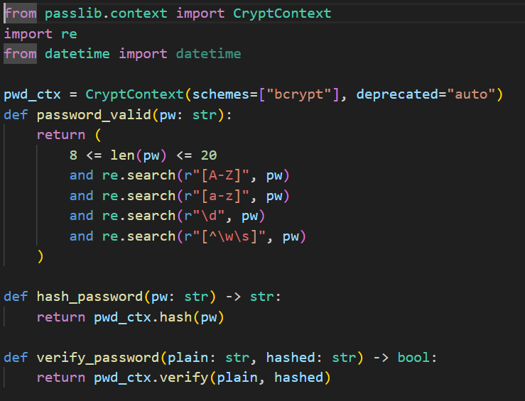

JWT-BASED AUTHENTICATION: -
In modern web applications, authentication is a critical security component. Traditional session-based authentication requires the server to store session data, which makes scaling difficult in distributed systems. To overcome these limitations, the project uses JSON Web Tokens (JWT) for secure, stateless authentication.
JWTs allow users to authenticate once (login) and then use a signed token for accessing protected resources without requiring the server to maintain session state.

What is JWT?
JWT (JSON Web Token) is an open standard (RFC 7519) used for securely transmitting information between parties as a JSON object.
JWTs are digitally signed using a secret key (HMAC) or public/private key pairs (RSA/ECDSA).
A JWT is compact, URL-safe, and commonly used for authentication and authorization.

Structure of JWT
A JWT consists of three parts, separated by dots (.): header. payload. Signature
Example JWT:
eyJhbGciOiJIUzI1NiIsInR5cCI6IkpXVCJ9.
eyJzdWIiOiJ1c2VyMTIzIiwicm9sZSI6ImFkbWluIiwiZXhwIjoxNjkzOTEwNDIzfQ.
U2h2R6Jw9eZCjz3PpYVwFGa5u8XgJcUt0SOTvYO7c2k

Header – Contains metadata, including the signing algorithm.
{
"alg": "HS256",
"typ": "JWT"
}
Payload – Contains user data (claims).
{
"sub": "user123",
"role": "admin",
"exp": 1693910423
}
Signature – Ensures token integrity. Created using the header, payload, and a secret key.

Why JWT in this Project?
- Stateless → No server-side session storage required.
- Scalable → Works well in distributed or microservice architectures.
- Secure → Tamper-proof if signed with a strong secret.
- Role embedding → User roles (admin, user) can be stored inside the token for RBAC.
- Expiry support → Tokens automatically expire after a set time, reducing misuse risk.

Implementation in the Project
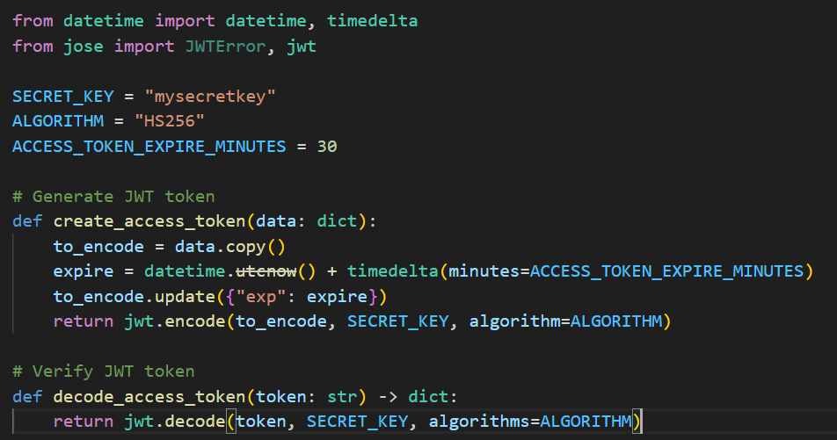

Login Endpoint

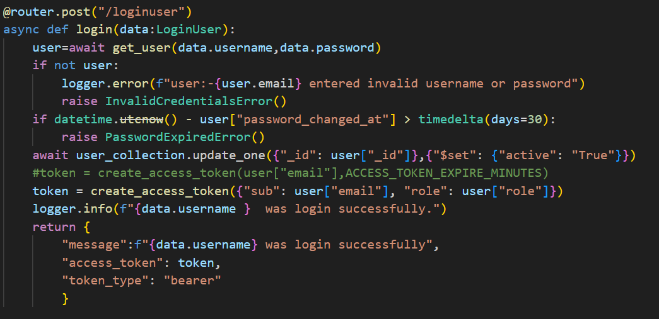

RATE LIMITING:-
In any web application, security is not just about authentication and encryption — it also involves protecting APIs from abuse. Attackers often try to brute-force passwords or flood the server with requests, leading to denial-of-service (DoS).To mitigate this, our project implements Rate Limiting, which restricts how many times a user or IP address can access a particular endpoint within a given timeframe.

What is Rate Limiting?
Rate Limiting is a security mechanism that:
Controls traffic to the server by restricting request frequency.
Helps prevent brute-force login attacks.
Protects APIs from abuse, spam, and denial-of-service (DoS).
Ensures fair usage among multiple clients.

Implementation in the Project
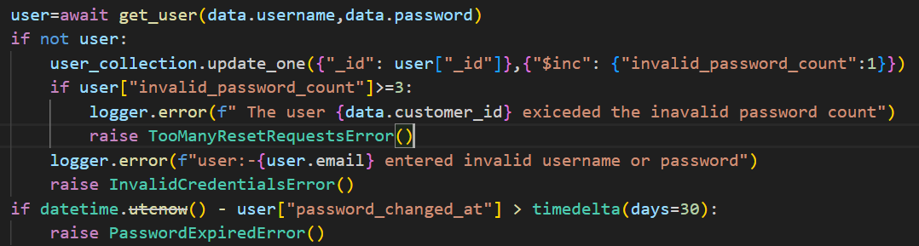

Input Validation:-
User inputs are one of the most common entry points for attackers. In this project by using pydantic base model we are validating the data it allows the only valid data if data is not valid it throws an error.

What is Input Validation?
Input Validation ensures that only correctly formatted data is accepted by the system.

Example:
Email should follow a valid pattern (name@example.com).
Password must be at least 8 characters, contain uppercase, lowercase, digits, and special characters.
Username must only contain letters, numbers, and underscores.

What is Pydantic?
Fast API uses Pydantic for data validation and serialization. At the center of this system is the BaseModel class, which allows developers to define the structure, validation rules, and constraints for input/output data. Instead of manually checking each input (like email, password, username), BaseModel ensures that invalid data is automatically rejected before it even reaches your business logic.

What is BaseModel?
- BaseModel is a Python class provided by Pydantic.
- You define your data models by creating a class that inherits from BaseModel.
- Each attribute in the class has a type (e.g., str, int, EmailStr), and FastAPI automatically validates requests against this model.

Implementation in the Project
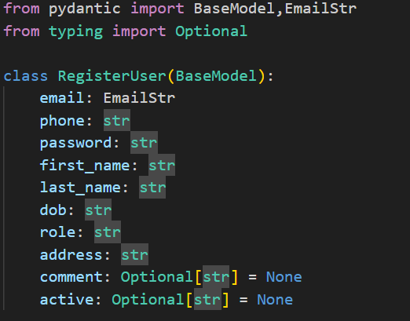

How BaseModel Works in Fast API
- When a request is sent to an endpoint, Fast API automatically Reads the request body.
- Validates it against the BaseModel. And Rejects invalid data with a 422 Unprocessable Entity error.
- If data is valid, it is converted into a Python object that you can use directly in your endpoint.

Advantages of Using BaseModel
- Automatic Validation – No need for manual if checks.
- Error Handling Built-in – Invalid inputs automatically return error messages.
- Clean & Readable Code – Define schema once, use everywhere.
- Type Safety – Prevents type mismatch errors.
- Serialization/Deserialization – Converts JSON ↔ Python objects easily.

Role-Based Access Control:-
In a secure application, not every user should have the same level of access.
For example:
- An Admin can manage users, view logs, and change roles.
- A Normal User can only access their personal dashboard.
This type of access restriction is called Role-Based Access Control (RBAC).
RBAC ensures that each user can only perform actions that are permitted to their role, preventing misuse and strengthening security.

Why RBAC is Important
- Prevents unauthorized access to sensitive data.
- Helps comply with data security regulations (GDPR, HIPAA, etc.).
- Makes permission management easier for large systems.
- Supports principle of least privilege (give only necessary permissions).

RBAC in Fast API
We can implement RBAC by:
- Embedding role information inside the JWT token when a user logs in.
- Using dependency functions (Depends) in Fast API to check roles before granting access.

Implementation in the Project
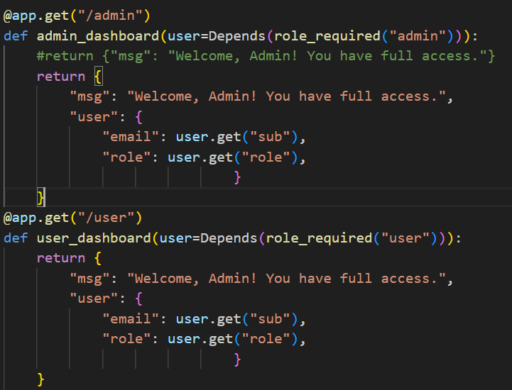
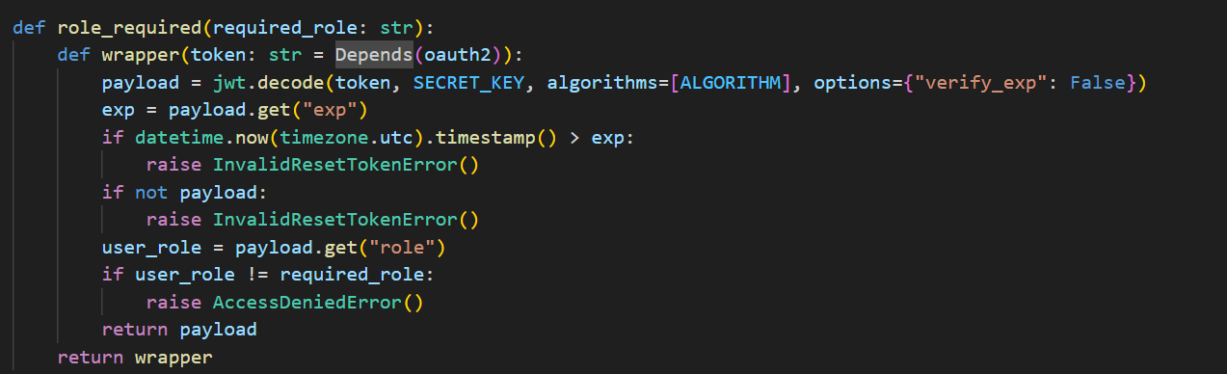

Advantages of RBAC
Security – Prevents unauthorized access.
Scalability – Easy to manage permissions as system grows.
Compliance – Aligns with best security practices.
Flexibility – Can easily add new roles (e.g., manager, moderator).

TLS/SSL Encryption: -
When a client (Postman, browser, mobile app) communicates with your FastAPI or Flask API, the data travels over the internet.If that data is not protected, attackers can intercept it using tools like packet sniffers (Man-in-the-Middle attacks).
TLS (Transport Layer Security) and its predecessor SSL (Secure Sockets Layer) solve this by encrypting data in transit.
- Without TLS → Passwords, tokens, and personal data are sent in plain text.
- With TLS → Data is encrypted before transmission, making it unreadable to attackers.

What is TLS/SSL?
- TLS/SSL are cryptographic protocols that secure communication over a network.
- They provide:
  - Encryption – Data is scrambled so attackers cannot read it.
  - Authentication – Confirms the server (and sometimes client) identity with certificates.
  - Integrity – Ensures that data is not altered during transmission.

How TLS/SSL Works
- Handshake Phase
  - Client connects to the server.
  - Server presents its SSL/TLS certificate.
  - Client verifies the certificate with a trusted Certificate Authority (CA).
  - Both agree on an encryption algorithm and session key.
- Data Exchange Phase
  - All communication (login requests, JWT tokens, sensitive data) is encrypted.
  - Only client and server can decrypt the data.

Security Event Logging: -
Security event logging is the process of recording and monitoring events related to security in an application. In this project, since we deal with sensitive operations like login, JWT authentication, and role-based access, logging is essential to:
- Track user actions
- Detect malicious activities
- Provide an audit trail for investigations
- Help administrators monitor system health

Why is it Important?
Without proper logs, it is impossible to know:
- Who logged in and when
- How many times login failed
- Which user attempted to access an admin-only route
- Whether JWT tokens are being misused or expired
Thus, logs act as the first line of defence in securing an application.

Events to Log
In this project, we should log:
- Login Events
  - Successful login (username, IP, time)
  - Failed login (reason, IP, user)
- JWT Events
  - Token generated (with expiry time)
  - Token expired
  - Token misuse (invalid/tempered)
- Authorization Events
  - Unauthorized access attempts
  - Role-based access denied (user trying to access admin endpoint)
- System Security Events
  - Rate limit exceeded

Implementation in the Project
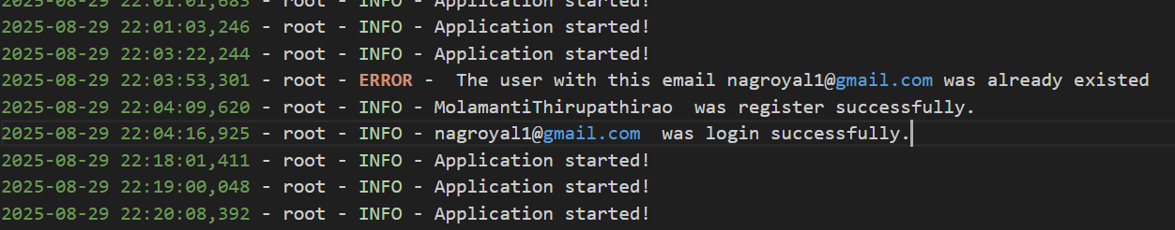

Demo Project: Secure Login + JWT + RBAC with Fast API and MongoDB: -

Objective
The objective of this demo project is to showcase secure authentication and authorization using:
- FastAPI as the backend framework
- MongoDB as the database
- JWT (JSON Web Token) for stateless authentication
- RBAC (Role-Based Access Control) for managing user permissions

Features Implemented
- User Registration – stores users with hashed passwords using bcrypt.
- User Login – generates JWT tokens upon successful authentication.
- JWT Authentication – every request must include a valid token.
- Token Expiry Handling – expired tokens are rejected.
- Role-Based Access Control (RBAC) –
  - Users with role "admin" can access admin routes.
  - Users with role "user" can only access user routes.
- Rate Limiting – prevents brute-force attacks.
- Security Event Logging – records login attempts, token expiry, and unauthorized access attempts.
- TLS Support – ensures encrypted communication.

Example API Endpoints
Authentication
- POST /register → Register a new user (password stored using bcrypt).
- POST /login → Authenticate user and return JWT token.
User Dashboard
- GET /user/dashboard → Accessible only by role "user".
Admin Dashboard
- GET /admin/dashboard → Accessible only by role "admin".
Security
- GET /token/verify → Verifies whether the provided token is valid or expired.

Flow of the Project
- User registers → password hashed using bcrypt and stored in MongoDB.
- User logs in → JWT token is generated and returned.
- User sends requests → token is validated on each request.
- Role checked →
  - If "admin", access admin routes.
  - If "user", access user routes.
  - If invalid role, access denied.
- Logs created → All authentication/authorization events recorded in security.log.

Project structure
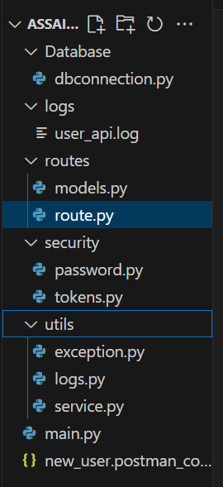

Requirements: -
- Operating System: Windows 10/11, Linux (Ubuntu), or macOS
- Programming Language: Python 3.9+
- Framework: FastAPI (for backend API)
- Database: MongoDB (with authentication enabled)
- Security Libraries:
  - bcrypt → for password hashing
  - python-jose or PyJWT → for JWT token management
- Web Server: Uvicorn / Gunicorn
- SSL/TLS: OpenSSL (for generating certificates in development)
- Development Tools:
  - Postman (for API testing)
  - Visual Studio Code / PyCharm (IDE)
- Package Manager: pip (for Python dependencies)

Conclusion:-
In this project, we successfully implemented a secure authentication and authorization system using FastAPI and MongoDB, following industry-standard best practices. The project demonstrates how sensitive user data can be protected through:
- Password Hashing with bcrypt, ensuring that even if the database is compromised, passwords remain secure.
- JWT-based Authentication, enabling secure, stateless session management.
- Rate Limiting, which helps prevent brute-force attacks and API abuse.
- Input Validation and Sanitization, protecting the system from injection and malformed data attacks.
- Role-Based Access Control (RBAC), ensuring that only authorized users can access protected routes.
- TLS Encryption, securing communication between client, server, and database.
- MongoDB Authentication and Role Management, restricting database access with minimum privileges.
- Security Event Logging, providing visibility into login attempts, unauthorized access, and token misuse.
The demo project showcased how these features can be combined to create a practical and secure system where users and admins have clearly defined permissions.

